**MMS-Project 2  
Game Development using HTML5**

Prepared by :  
1) Ahmed AlaaElDeen Abdel Fattah 828  
2) Mazen Mohamed Melouk 1067

**i) Complete Description of game logic:**The game starts with the main menu scene along with the background music as a start, the page waits for the user to click "fire a bullet at the start button to initiate the game.  
  
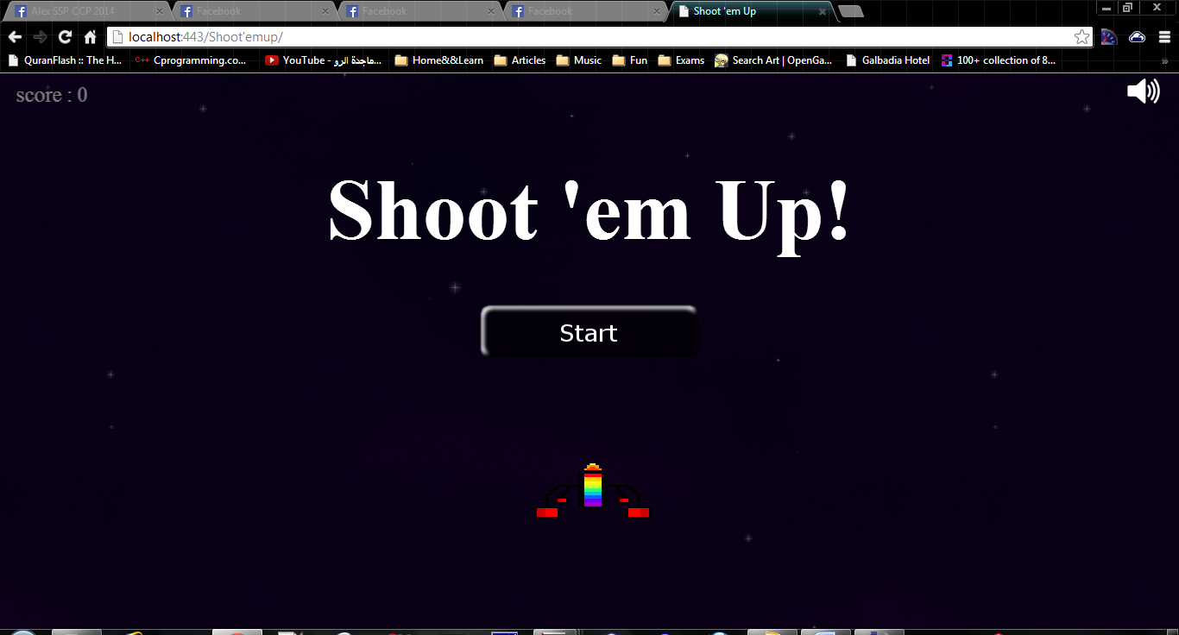

Then the game start with basic level 1 which includes the following:  
 1- Special sliding background  
 2- Special background Music  
 3- Simple Enemies that just travel vertically downwards, player loses if a collision occurs  
 4- Falling FireBalls, these are fire balls that fall at a high speed & could destroy the player  
 5- Rewards that occurs every multiple of the score these includes   
 - A shield that is valid until the player colloides with an enemy or a fireball  
 -A round of Multi-Bullets, fire 3 bullets instead of one with a higher score for special hits  
 -A blast bomb, this blasts all enemies currently on screen.  
  
Generally, the game can be paused/unpaused, mute/unmute, exit to main menu via keyboard buttons "p","m" & "c" respectivly.  
However the game automatically pauses when navigating away from the game page/tab.

After collecting a certain score the player is moved to level 2 which has same features as level 1 & additional features:  
 1) Fireballs & enemies are created & move faster  
 2) Smarter enemies which move to towards the player's position increasing the difficulty   
 3) Smarter enemies need 2 hits to die

**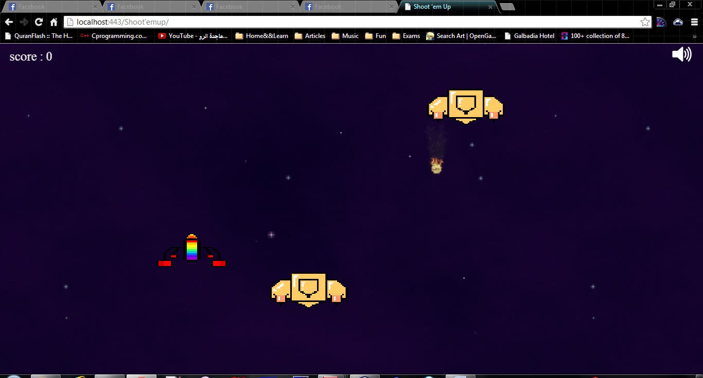  
  
A scene from level 1 where there is a player, 2 enemies & a fire ball  
  
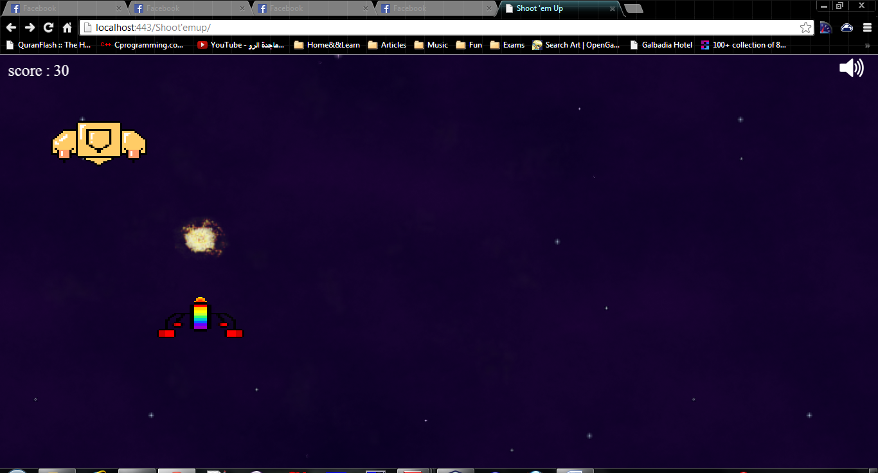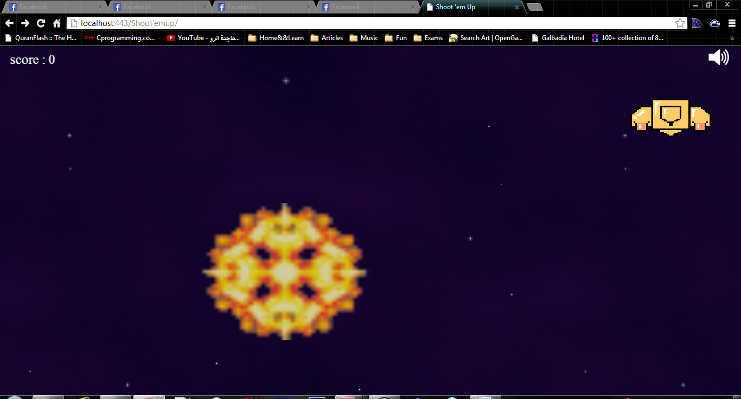  
  
A scene showing the blast caused by hitting an enemy , on left & it is animated by varying multiple images with a increasing width & height while decreasing transparency "alpha" till disappearance**

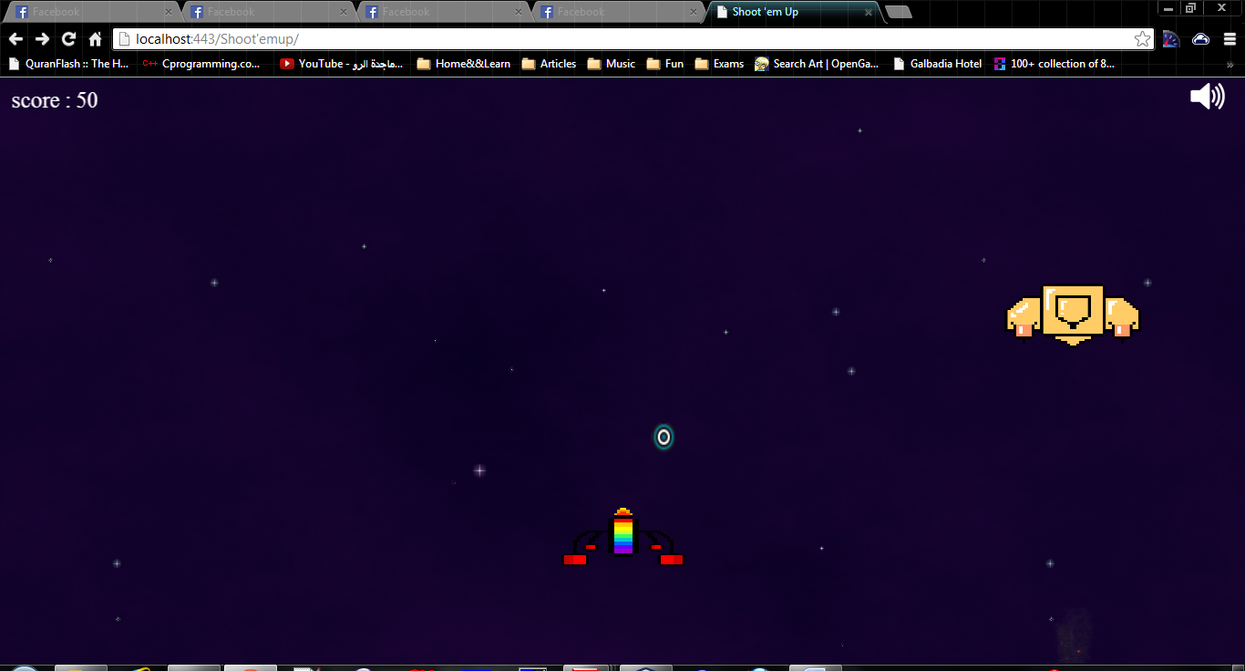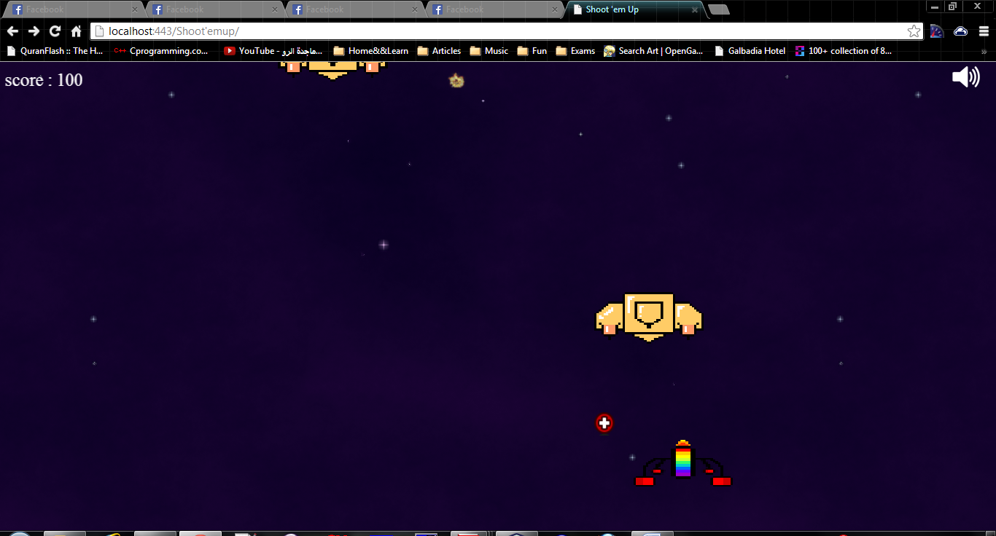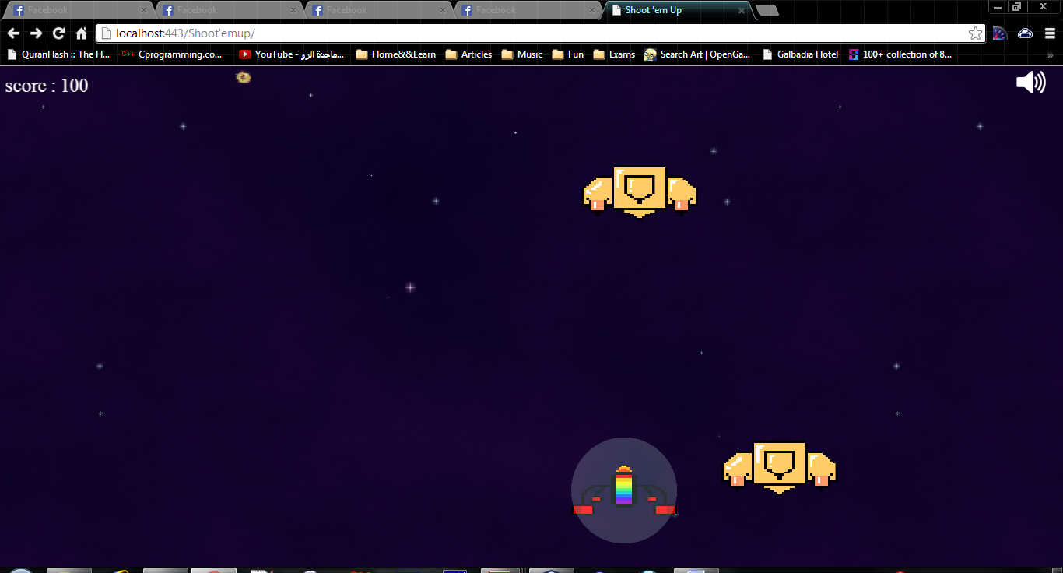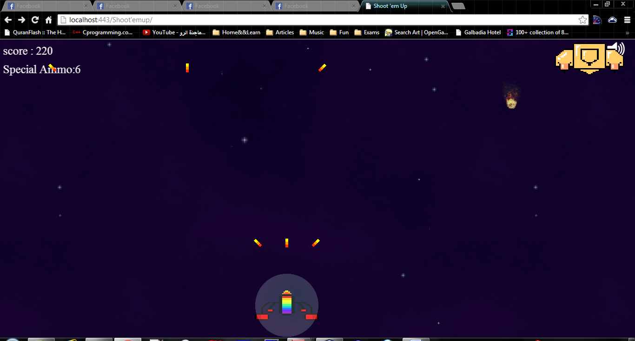

These image show rewards falling & their effects, the blue one would blast all enemies on screen, red one would shield the player & protect it from losing if collided with an enemy or fireball. Finally the multi-bullet function allows the player to fire 3 bullets with an angle & a definite number as shown below the score.

Another aspect is the game controls, when pausing a black screen with a small alpha pops with paused in the middle & a resume button, also muting/unmuting   
could be observed via the speaker icon in the top right corner .  
Also navigation away from the window shall pause the game until the cursor is back to game screen.  
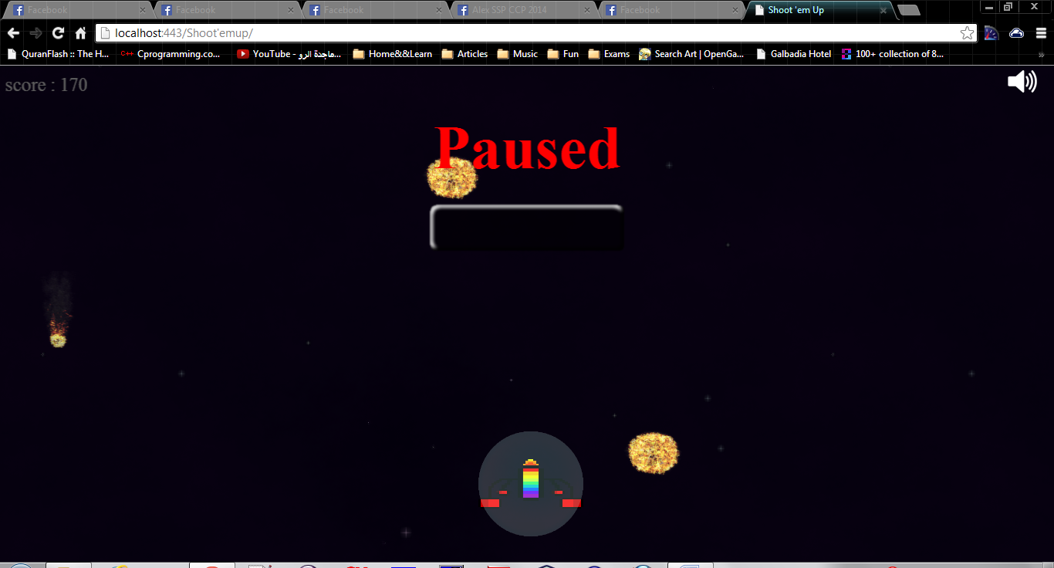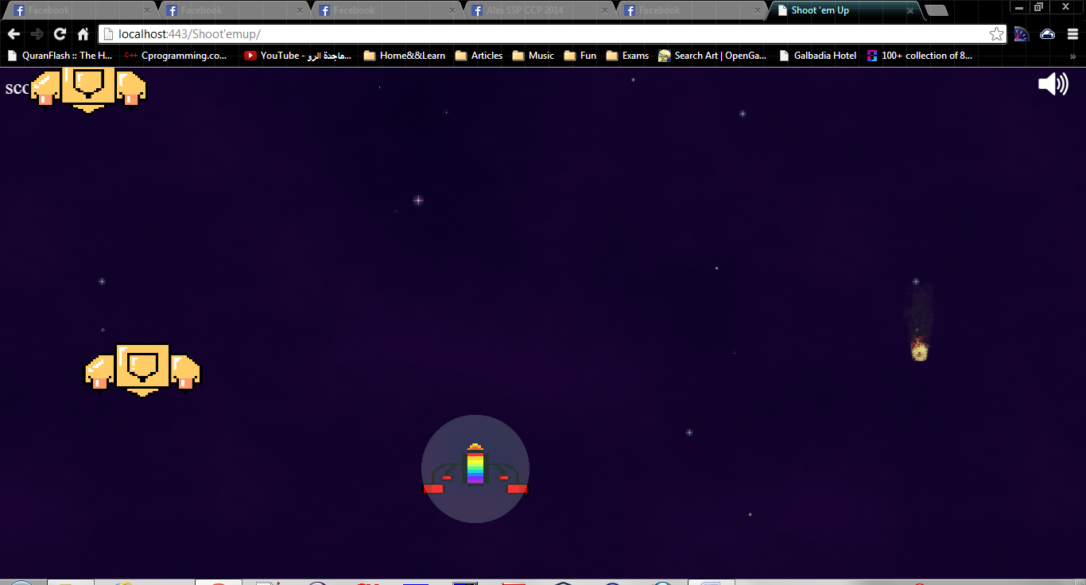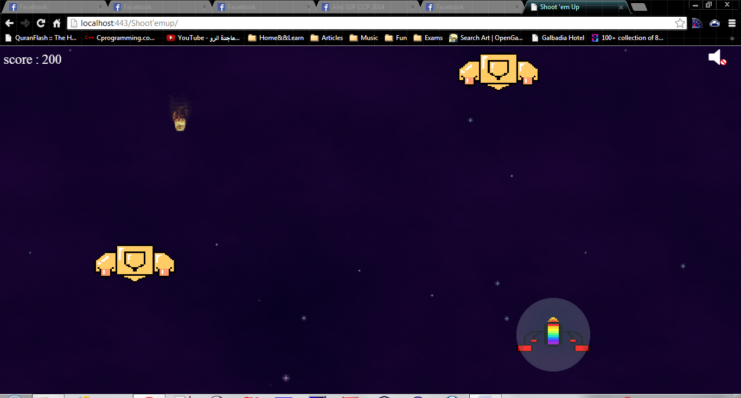  
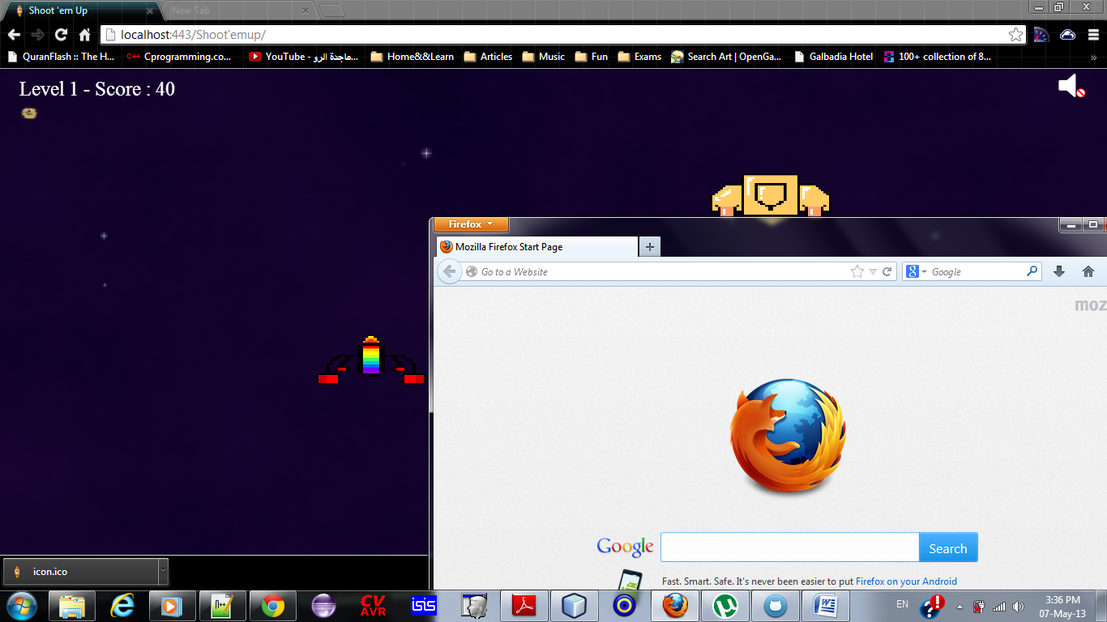

**ii) Technology used:**

As required " pixi.js " as a 2D webgl renderer was used   
  
[https://github.com/GoodBoyDigital/**pixi**.js](https://github.com/GoodBoyDigital/pixi.js)  
  
Also "jQuery.js" is used for some extra features & events as timer function & clicks  
  
<http://jquery.com/download/>  
  
NetBeans as IDE for a smooth coding experience

Google Chrome Debugging tools

**iii) Testing on different browsers :  
  
a- Google Chrome :** 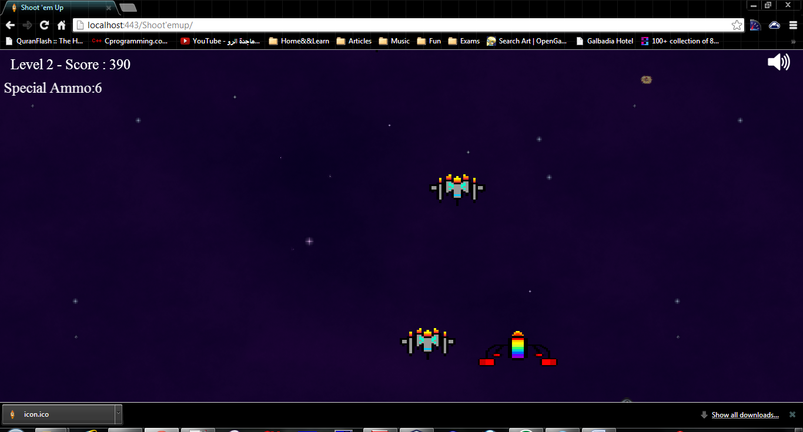

**b-Fire Fox :**

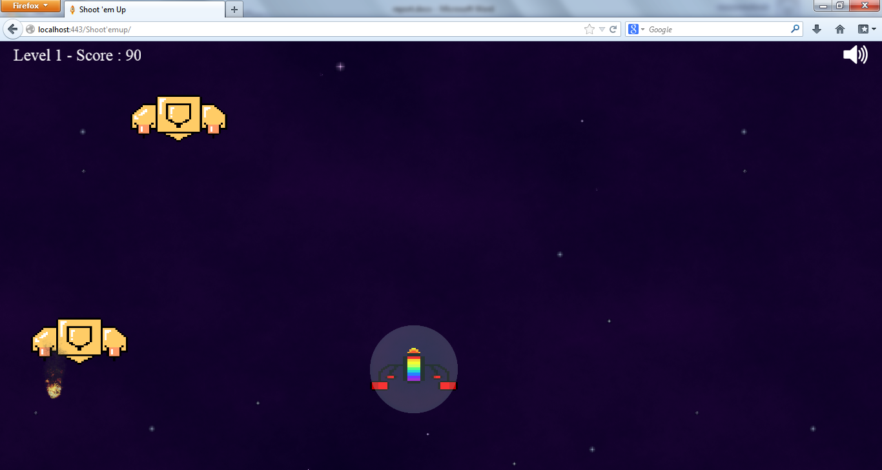

**iv) Code Snippets :**

The project folder is divided into folders according to contents that is js for javascript files , css for style sheets, img for images ....etc  
  
Most of the work is through java scripts, apart from downloaded scripts "pixi.js" & "jQuery.js" , other files are labeled to give a hint about what their function is for example :   
global.variables.js , would have all global variables defined  
sound.js, would have all functions controlling sound & volume.  
  
Most of the code is "event.detections.js" which detects events such bullets hitting an enemy, player colliding with an enemy, code snippets from the file are shown below:  
  
function detectPlayerFireBallCollision() {

for (i = 0; i < fireballs.length; i++) {

if (detectCollisionFireBall(fireballs[i].sprite, Sprites.player)) {

if (shielded) {

shielded = false;

detectPlayerFireBallCollision is a function to check if player collides with fireball, if player is shielded ,then remove shield else blast to animate players death

stage.removeChild(Sprites.shield);

stage.removeChild(fireballs[i].sprite);

fireballs.splice(i, 1);

return;

}

dead = true;

$("body").css("cursor", "auto");

playSound("bigBlast");

Sprites.playerBlast.position = getCenter(Sprites.player);

stage.removeChild(fireballs[i].sprite);

fireballs.splice(i, 1);

stage.addChild(Sprites.playerBlast);

stage.removeChild(Sprites.player);

return;

}

}

}

function detectBulletEnemyCollision(bulletsArray) {

var i, j;

for (j = 0; j < enemies.length; j++)

for (i = 0; i < bulletsArray.length; i++) {

if (enemies[j].injuries >= enemyTypes.maxInjuries)

return;

if ((detectCollision(bulletsArray[i], enemies[j].sprite) && getBottomRight(enemies[j].sprite).y > 5)) {

var enemyBlast = {

animIndex: 0,

associatedEnemy: enemies[j],

deltaXY: getCenter(enemies[j].sprite)

};

enemyBlast.sprite = new PIXI.Sprite(new PIXI.Texture.fromFrame(cacheIndices.explosion1.start));

enemyBlast.sprite.anchor.x = enemyBlast.sprite.anchor.y = 0.5;

enemyBlast.sprite.position = getCenter(bulletsArray[i]);

enemyBlast.sprite.width = enemyBlast.sprite.height = enemies[j].sprite.width / 2.5;

score += 10 * (currentLevel + 1) * (enemyTypes[enemies[j].type].scoreFactor)

* (enemies[j].injuries+1);

if (score>=Level[currentLevel].scoreStep)

LevelUp();

playSound("blast");

enemyBlasts.push(enemyBlast);

stage.addChild(enemyBlast.sprite);

stage.removeChild(bulletsArray[i]);

bulletsArray.splice(i, 1);

enemies[j].injuries++;

enemies[j].oscNo = 0;

enemies[j].oscDir = 'right';

enemies[j].oscPos = 0;

if (enemies[j].injuries < 2) {

switch(enemies[j].type){

case 0:

enemies[j].redMask = new PIXI.Sprite(Textures.enemy1Red);

break;

case 1:

enemies[j].redMask = new PIXI.Sprite(Textures.enemy2Red);

break; }

enemies[j].redMask.alpha = 0;

enemies[j].sprite.addChild(enemies[j].redMask); }

if (enemies[j].injuries >= enemyTypes[enemies[j].type].maxInjuries)

enemies[j].state = 'dying';

else { enemies[j].state = 'hurting'; }

if ( (score - prevScore)>=Level[currentLevel].bonusStep && sendGift) {

giftIsActive = true;

sendGift = false;

spawnPowers();

prevScore = score;

}

else {

sendGift = true;

}

}

}

}

Some function from "event handelers.js" which handles events as mouse clicking or navigation away from screen are shown below:

function clickFunction() {

if (cantClick || dead || paused)

return;

var bullet = new PIXI.Sprite(Textures.playerBullet);

bullet.width = Sprites.player.width * 0.04;

bullet.height = Sprites.player.height * 0.3;

bullet.anchor.x = 0.5;

bullet.anchor.y = 0.5;

bullet.position.x = getCenter(Sprites.player).x;

bullet.position.y = getTopLeft(Sprites.player).y - bullet.height / 2.0;

stage.addChild(bullet);

bullets.push(bullet);

playSound("bullet");

if (multigunned) {

bonuslimit--;

var right, left;

right = new PIXI.Sprite(Textures.playerBullet);

left = new PIXI.Sprite(Textures.playerBullet);

right.width = left.width = Sprites.player.width * 0.04;

right.height = left.height = Sprites.player.height * 0.3;

right.anchor.x = left.anchor.x = 0.5;

right.anchor.y = left.anchor.y = 0.5;

right.position.x = left.position.x = getCenter(Sprites.player).x;

right.position.y = left.position.y = getTopLeft(Sprites.player).y - bullet.height / 2.0;

right.rotation = 0.78532981625;

left.rotation = -0.78532981625;

stage.addChild(right);

stage.addChild(left);

bulletsR.push(right);

bulletsL.push(left);

if (bonuslimit < 0)

{

multigunned = false;

stage.removeChild(Texts.counterText);

}

}

cantClick = true;

$.timer(function() {

cantClick = false;

}).once(clickDelay);

}

**v)Github link:**  
project files are uploaded on Github @  
<https://github.com/mazenmelouk/HTML5GameDev>